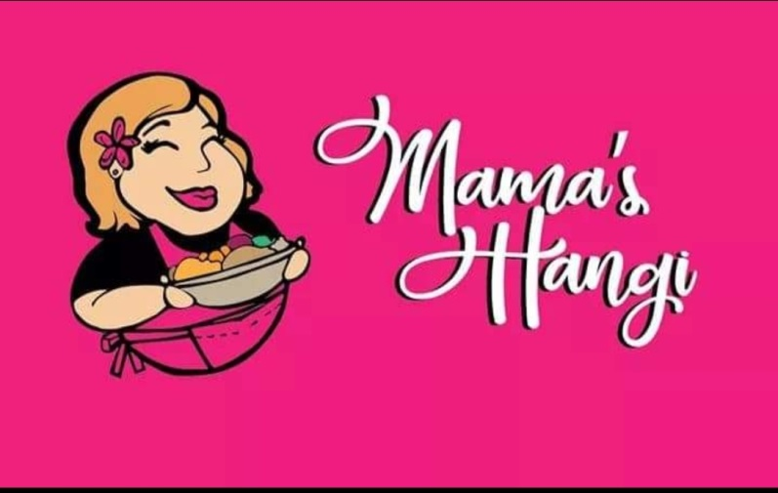
NZ Heritage Hockey Tournament
Team Pre Order Form
Kai Will Be Available From Friday Evening through to Monday
Team Manager please email your team order to
Mamashangi01@gmail.com Lydia 0210713749
Before 12pm each day to place order for following day as there are Daily Limits on each item

Team Name: ………………………………………………………………… PASIFIKA MENU
Team Manager Name: ……………………………………………………
Mobile: …………………………………………………………………
Email: ……………………………………………………………………………….
NAME | Option 1  Mama’s Pasifika Plate  Honey Soy Chicken,  Beef Chop Suey, Rice  Choice of  Mainaise or Crabmeat  Salad  $13.00 | Option 2  Mama’s Pasifika Plate  Sticky Roast Pork,  Beef Chop Suey, Rice  Choice of  Mainaise or Crabmeat  Salad  $13.00 | Option 3  Palusami – Lu –  Rukau Packs  Taro leaves with Corned Beef  Onion & Coconut cream  $7.00 | Option 4  Beef Chop  Suey & Rice  $7.00 | Option 5  Mainaise  Cook Island  Potato Salad  $7.00 | Option 6  Ika Mata  Raw Fish  Travelley marinated in  Lemon coconut cream onions tomato Capsicum  $8.00 | Option 7  Otai  Island Fruit Drink  Freshly Grated Coconut Mango Orange Apple Watermelon  $7.00

