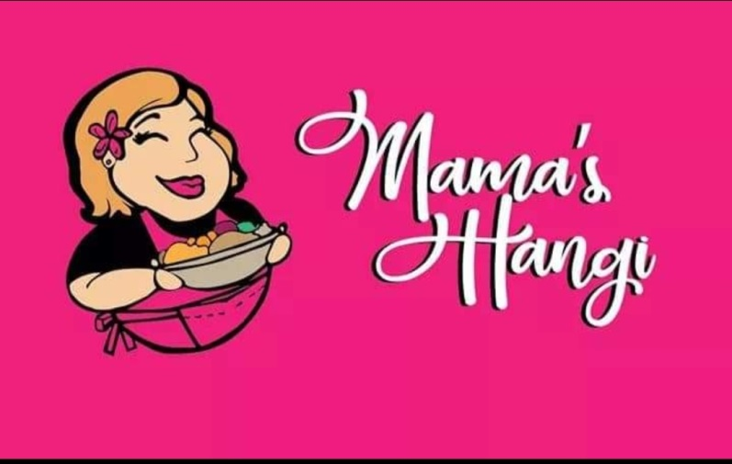
NZ Heritage Hockey Tournament
Team Pre Order Form
Kai Will Be Available From Friday Evening through to Monday
Team Manager please email your team order to
Mamashangi01@gmail.com Lydia 0210713749
Before 12pm each day to place order for following day as there are Daily Limits on each item

Team Name: ………………………………………………………………… MAMA’S HANGI MENU
Team Manager Name: ……………………………………………………
Mobile: …………………………………………………………………
Email: ……………………………………………………………………………….
PLAYERS NAME | Option 1  Pork & Chicken  Hangi with  Potatoes,  Kumara,  Pumkin,  Cabbage,  Mamas  Stuffing  $13.00 | Option 2  Chicken  Hangi with  Potatoes,  Kumara,  Pumkin,  Cabbage,  Mamas  Stuffing  $13.00 | Option 3  Pork  Hangi with  Potatoes,  Kumara,  Pumkin,  Cabbage,  Mamas  Stuffing  $13.00 | Option 4  Vegetarian  Hangi with Potatoes,  Kumara, Pumkin,  Cabbage,  Mamas Stuffing  $13.00 | Option 5  Vagan  Hangi  Seasonal  Vegetable With Chick Pea  $13.00 | Option 6  Fry Bread  Sliders  Hangi  Pork  With Mamas  Stuffing  $8.00 | Option 7  Fry Bread  With Butter & Golden syrup  $2.00 | Option 8  Mamas Steam  Pudding With  Custard  $6.00 | Total $

